**SHELL SCRIPTING IN LINUX OPERATING SYSTEM**

**EXAMPLE 1 : SHELL SCRIPT TO DISPLAY CURRENT DATE**

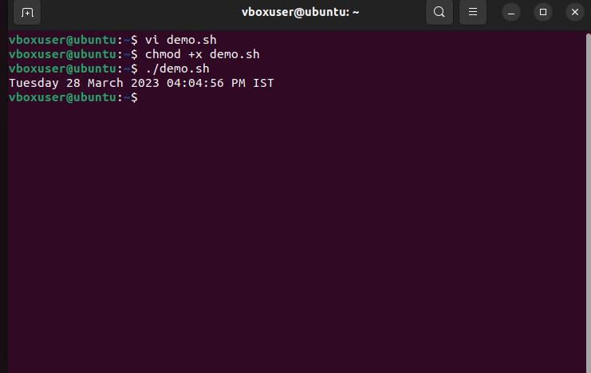

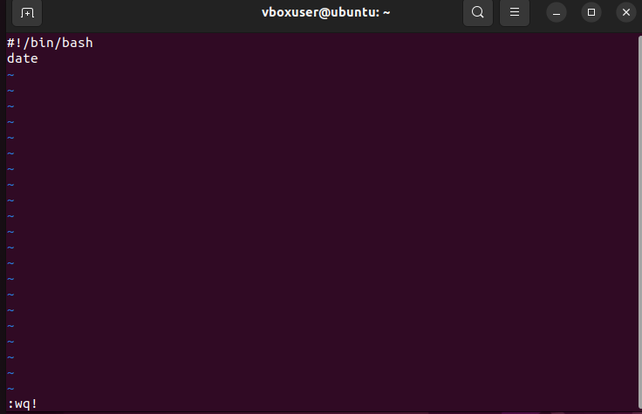

**EXAMPLE 2 : SHELL SCRIPT TO DISPLAY YOUR NAME**

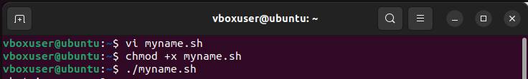

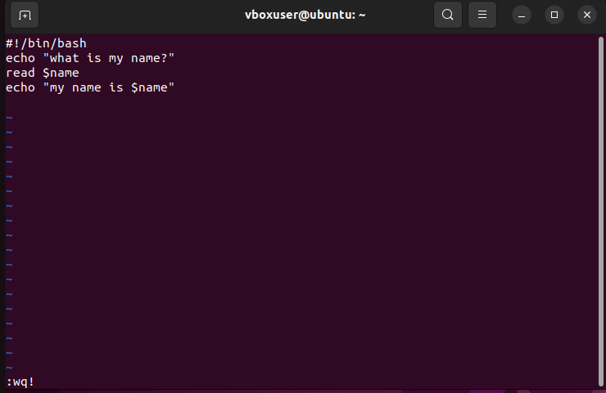



**EXAMPLE 3 : SHELL SCRIPT TO DEMOSTRATE VARIABLE**

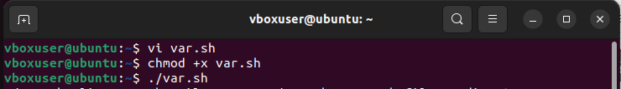

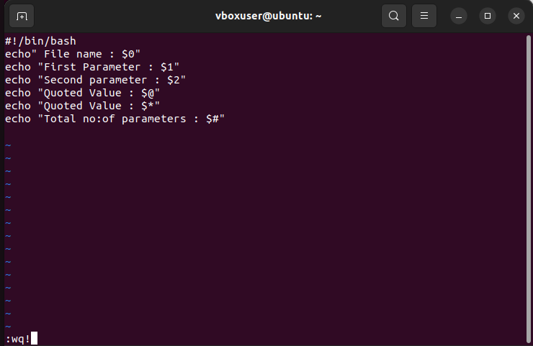

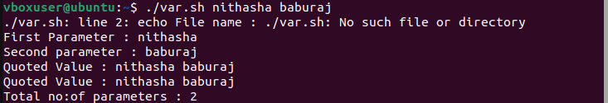

**EXAMPLE 4 : SHELL SCRIPT TO COUNT NO:OF LINES**

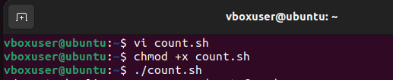

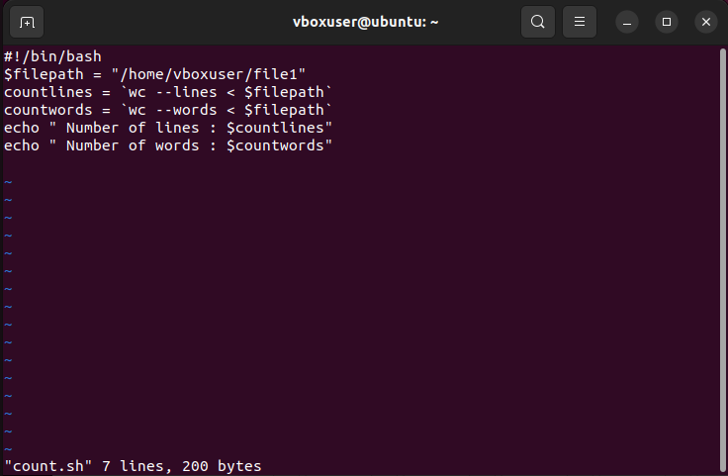

**EXAMPLE 5 : SHELL SCRIPT TO DISPLAY AN ARRAY**

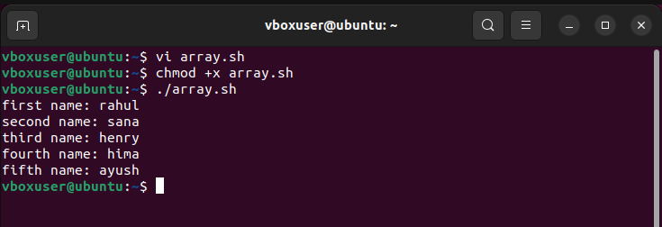

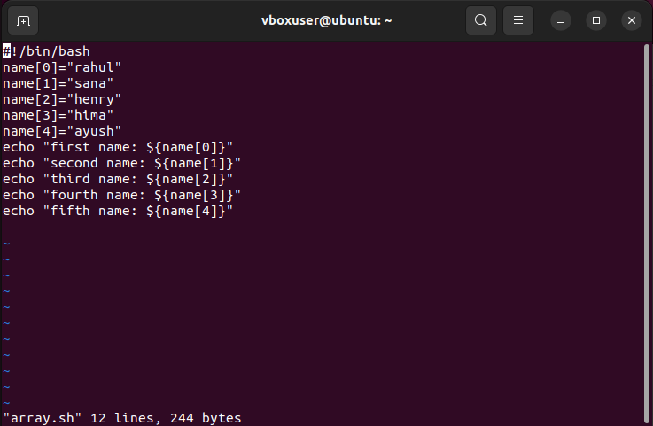

**EXAMPLE 6 : SHELL SCRIPT TO ADD 2 NUMBERS**

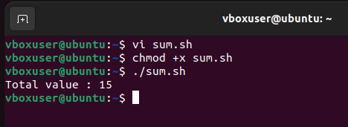

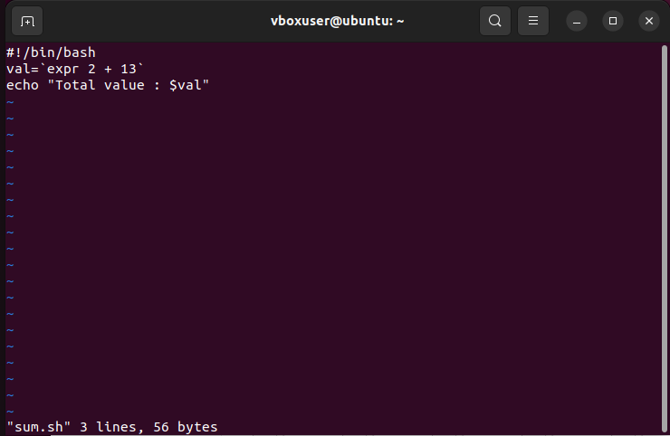

**Write an example shell script to initialize 2 numeric variables. Then perform an addition operation on both values and store result in third variable.**

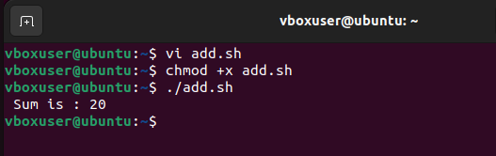

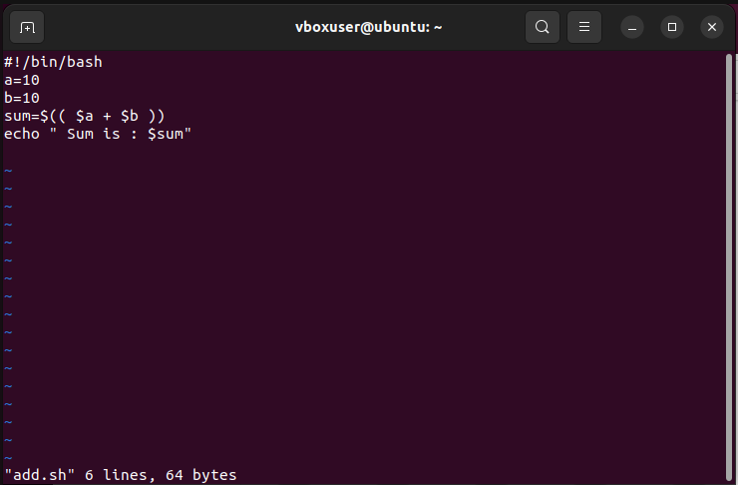

**Shell script to read 2 numbers as command line parameters and perform the addition operation.**

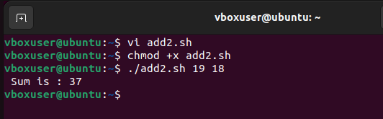

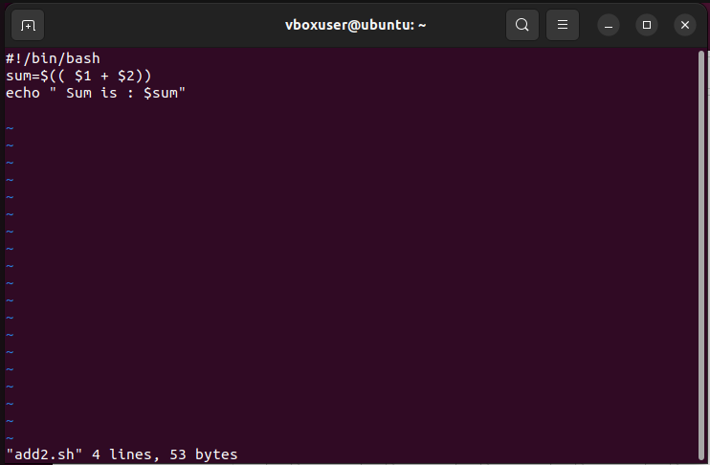

**Shell script that input from user at runtime. Then calculate sum of given numbers and calculator.**

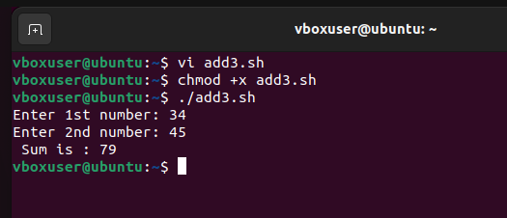

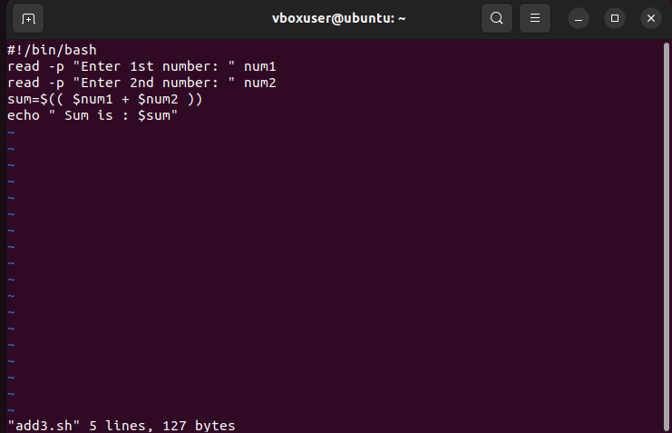

**ARITHMETIC OPERATORS**

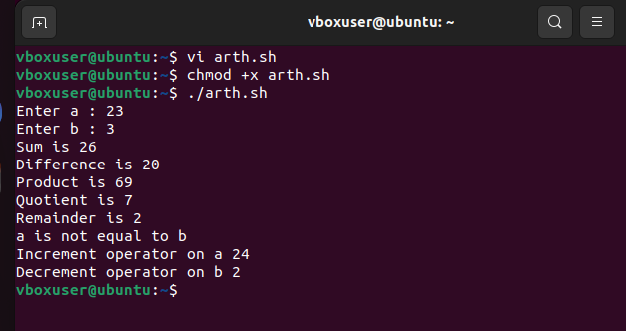

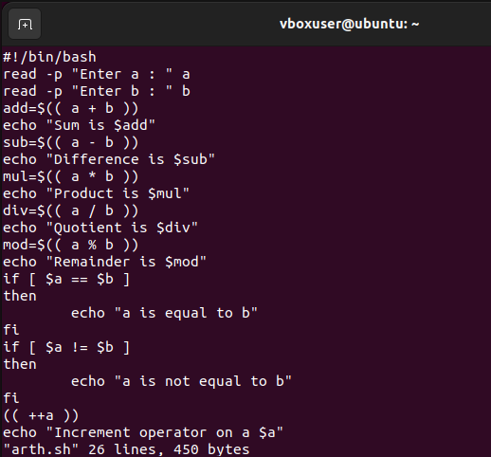

**RELATIONAL OPERATORS**

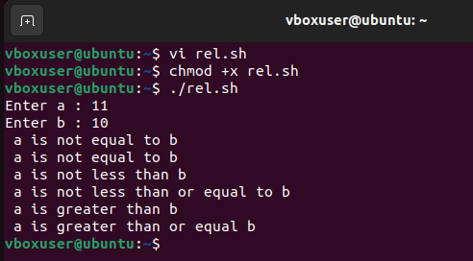

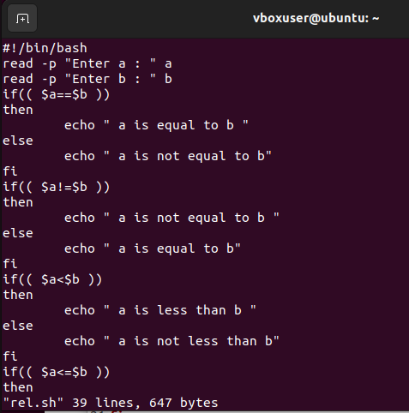

**Shell script to check whether the number is odd or even**

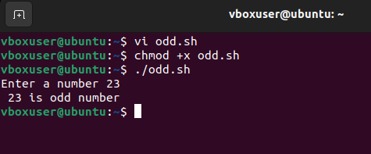

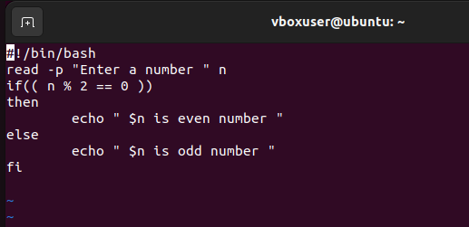

**Shell script to check whether a number is positive or negative**

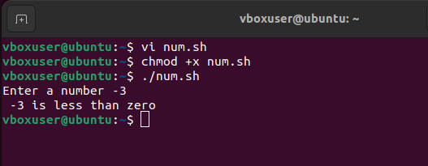

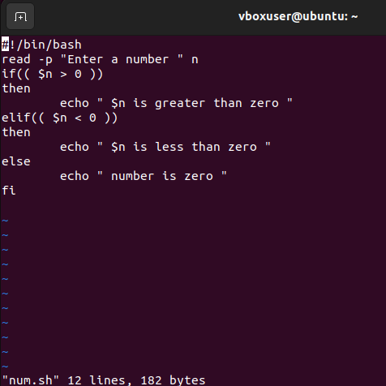

**Shell script to check which among the 2 numbers is largest.**

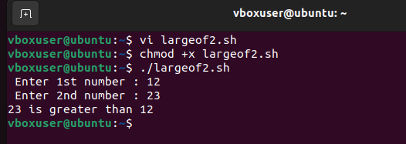

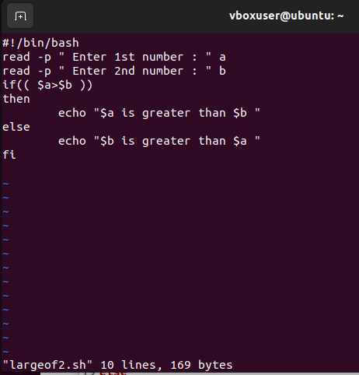

**Shell script to check which among the 3 numbers is largest.**

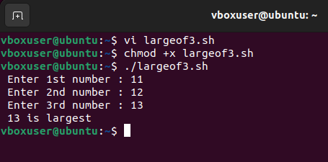

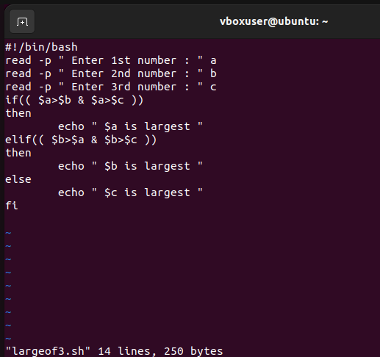

**Shell scrip to perform string operator**

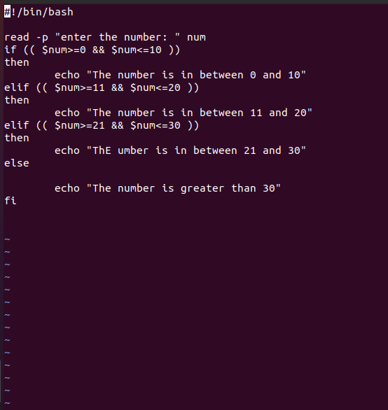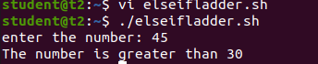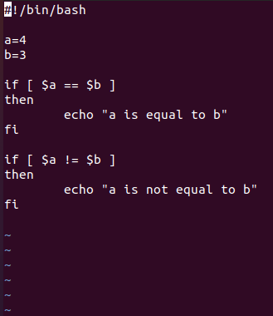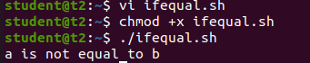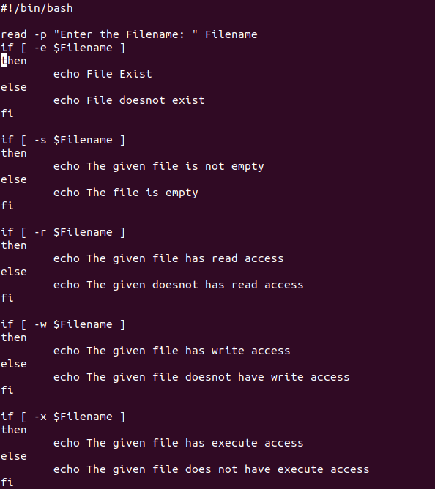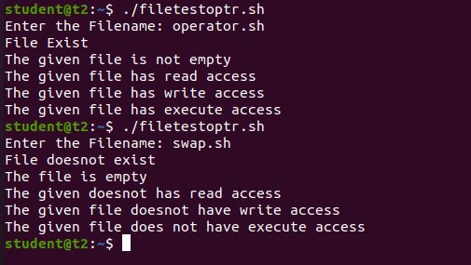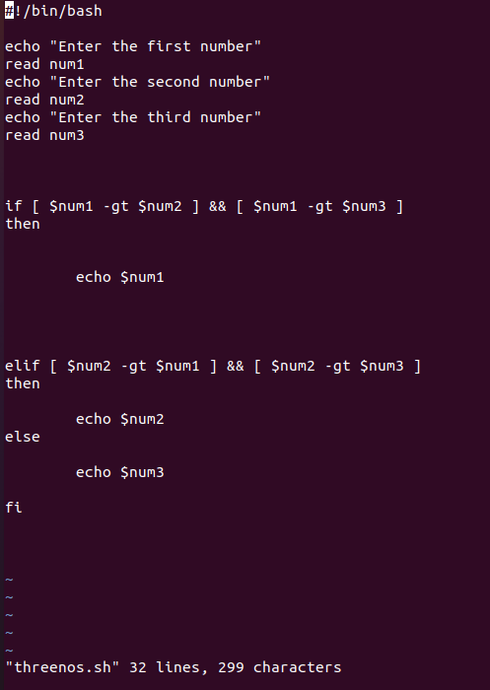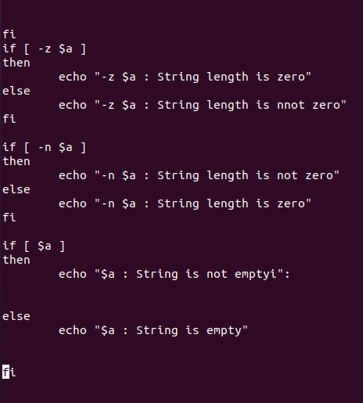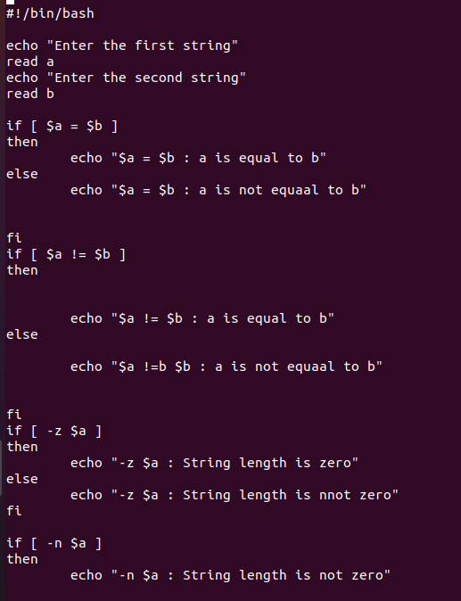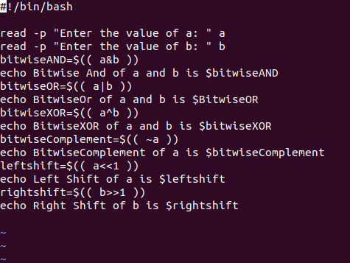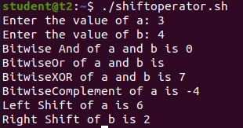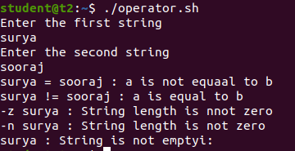

**Shell Scrip to check the range of a number using elseif ladder.**

